УДК 004.4.2(045)
P. Prystavka¹
A. Rogatyuk²

MATHEMATICAL PROVIDING OF RECOGNITION AND MAINTAINING OF MOVING OBJECTS IN REAL TIMEFOR VIDEO
National Aviation University,
Official address: National Aviation University, Ukraine, Kiev, Kosmonavta Komorova ave. 1,
E–mail: ¹chindakor@mail.ru, ²arogatuk@gmail.com
The classification and analysis methods of movable object are considered. А modification of method of classification and maintaining moving target based on the histogram estimation method and identify the moving points method based on frame-to-frame difference method is offered. These algorithms are used to develop the information technology of video processing.
Keywords: classification methods; maintaining moving targets; recognitions moving object; video data processing.

Description of the problem
During the last decade with the development of computer technology has become feasible and promising research methods and data processing technologies in digital video stream. One important issue in this direction is the need for recognition of moving objects in video in real time, which at present is not fully resolved. An moving object in the video we mean an object whose coordinates on each video frame changes relative to other objects in the scene. An moving areas of the video we mean an areas of the video frame that covering a moving object.
Because video data are presented as a set of consecutive frames bitmap, methods of classification of a moving object in the video based on recognition methods in the picture. One of the main requirements for such methods is the performance because the classification should be carried out in real time. So important not only to develop accurate methods of classifying objects but simple for effective implementation. Simple mean low computational complexity method to implement the appropriate software.
Such research is important for develop various means of visual observation as stationary (security systems, traffic control, etc.) and mobile, such as processing, video from unmanned aircraft.
The basis of the issues is research approach to digital video processing for detection and maintenance moving objects based on simple and fast methods, based on a comparison of histograms of some sections on video frames.
Analysis of publications
An maintenance we will mean determining the location of the object of observation after fixation during his stay in the area "vision" camera. The difference between the recognition of the moving object and detection is that in a situation of excess moving objects one or more specific objectives that meet specific criteria chosen for further analysis and maintenance, and other moving objects are ignored.
Consider some of the existing methods of recognition and maintenance of a moving object in the video. In [2] identified the general requirements for algorithms:
– a low computational complexity and work in real time;
– reliable detection at different times of day in the presence of artificial lighting;
– reliable operation at any time of the year in any weather conditions.
In [7] describes the basic algorithm of frame-to-frame difference method when processing RGB color video format, which looks like this:
– the algorithm receives two video frames that represent like two sequences of bytes in the format RGB;
– calculated frame-to-frame difference by pixel;
– calculate the average value between the values ​​of the three color components of each pixel;
– аverage value is compared with a given threshold.
As a result, formed a binary mask, one element of which correspond to the three color components pixel of two frames. Units in a mask placed where perhaps existing moves, but at this point there may be an individual items mask that mistakenly installed as unit. As the two input frames, you can use two consecutive frames from the stream, but you can use frames with large intervals, for example, which is from one to three shots. This method is easy to implement. The downside is fixing equipment noise during data recording.
In [1] to find correct localization and identification of objects is considered difference between the current frame and the base frame (frame background). In the method of the base frame affect to the quality of detection significantly the accumulation of basic frame, as it should have several properties:
– if the frame is a real picture frame, it has minimal delay time of the current frame;
– if artificially prepared base frame, it must contain a minimum number of moving elements, otherwise unavoidable false alarms on objects where the current frame is gone, but the basic frame contains some of the elements;
– minimum noise.
Before upgrading the base frame should to make filtering [7].
That is the main goal in the formation of the background frame is not the assumption of inclusion of areas where detected movement. The advantage of this method is less sensitive to noise in the image scene.
The difference between the methods frame-to-frame difference method and background selection is as follows:
– to obtain a reasonable estimate of the background being used dozens of frames, while the frame-to-frame difference is essentially the same, but the assessment of background images using the previous frame;
– on the previous frame objects accommodation nearly the same positions as the next, resulting in signal attenuation for homogeneous objects as opposed to background estimation algorithm in which the signal in large areas of the object itself is not subtracted from itself as a background [5].
– estimate of background requires more frames, making it difficult to perform the procedure, thereby reducing the performance of the algorithm.
The identification process based recognition method using templates based on patter recognition lies in the fact that the image of an unknown object is compared with the well-known images that are stored in the database. The identification process can be divided into three major phases: registration and normalization of images, distribution of characteristics, classification.
Morphological method [7] is the image analysis regarding the form of objects. Mathematical morphology is used in different systems that use image processing at different stages and for different purposes:
– improving the visual characteristics of the image (brightness, contrast, etc.);
– restoration of damaged images, such as restoration of images;
– detection contour;
– noise reduction.
Correlation function of two images should to produce a single maximum only when two identical images. The maximum value of the function at full convergence of the first raster with raster box on the second will be unit. The disadvantage of the method of correlation is high computational complexity.
One of the algorithms that directly follows a moving object in the frame – a tracking algorithm for the center of mass of the object, which is discussed in [4]. The idea of ​​the algorithm – find the center of each object and monitor its subsequent displacement. The essence of this algorithm is that the color components of each pixel frame sequence compared with that pixel (etalon) in which the program was recorded the motion before by the formula:
(1)
where r, g, b – an etalon pixel color components;
rc, gc, bc – color components of the current pixel that is processing.
The results of calculations of formula (1) for each pixel written to the matrix A. After reducing the frame rate and calculate all the values ​​selected several elements of the matrix A, with the lowest value among the corresponding coordinates (i, j) calculate the average value as the coordinates of the center of mass will be. The disadvantage of this algorithm is the high computational complexity [4].
From the analysis of these methods follows the need to develop methods based on these modified methods of recognition and maintenance moving target for the video. Formally, the problem statement is as follows: let the frames presented as an array:
(2)
where – streaming video frame at ms;
– the number of frames.
Each frame contains a sequence of pixels ,
where – color component of raster,
– the index of the pixel raster, – in charge for the horizontal pixel coordinate of where – the size of the picture horizontally, in charge of the vertical coordinate of the pixel, where - the size of the image vertically (top left pixel has coordinates ).
The purpose of work.
Let on the video frame recorded (in any way) moving object centered at coordinates , in the future we will call this object etalon. Let our goal is in the frame to determine the coordinates of the center of the moving object .
The main part.
First, for object define a moving area. With an appropriate set of k video frame select subset :
, , ,
where - the quantity that specifies the square border of moves area. Further sequence assume an etalon.
As control samples in the frame fix the set of moving objects with centers at the points, and

,
,
, ,
where – number of control samples, .
Each object is given as a corresponding sequence of pixels:
,
,
.
Using the methods of classification, we find from sequence object that meets the object .
To pre-processing, each of the sequences , , represent as one-dimensional arrays of data:
,
where – color raster element, which can be represented as:
– decimal three pairs of hexadecimal digits (for example # ffffff):
; (3)
– RGB color model, where:
. (4)
With the original data set in the form (3) for histogram estimation for the entire axis of a uniform partition with the step where the point: , ,
– the number of elements of the partition.
Make a count of the number of observations from the original sample who were in every element partitioning:
, ,
where
For each element partitioning calculate relative frequencies , resulting in an array obtained
If the initial data set is presented in the form (4), so the histogram is a graphic representation of the frequency dependence of falling values ​​of brightness of pixels being analyzed by grouping interval that contains 256-th frame brightness values​​:
,
where – the number of pixels with amplitude within the aperture of the test image;
– quantum amplitude levels contained in the range , ;
– total number of pixel values ​​in the analyzed image. (As performed by Histogram estimate the other two components - ).
The result is an array
Note that this method does not exclude the possibility of combining the components of RGB color model. Suppose we have estimate histogram etalon sample as an array of data:
histogram estimates of corresponding control samples:
Based on these estimates, we introduce the rules of the respective control sample with etalon: based on the minimum distance between histograms and interval method.
Consider a rule based on the minimum distance between histograms. Determine the Euclidean distance between the histogram estimates of the reference sample and control samples:
,
where
The result is an array of distances:

We assume that the reference sample , the most similar to if .
In real any moving object in the video that change its position can change its size and can visual texture change. So components of a color raster of the same point on the object can vary within a certain range. Therefore, it is reasonable to use the methods of classification, based on a comparison of the values of histogram samples in certain ranges.
In the interval method, on the basis of the etalon data defined intervals throughout the domain of the histogram, for which the total relative frequency of getting the intensity values ​​of pixels will not exceed a predetermined value , and the maximum amount of any successive periods not exceed zero value .
The result is an array of intervals:
,
where – the number of intervals, ,
For each control sample determined:
.
We assume that the etalon sample of the sequence , as similar to if .
According to these methods performed classification of moving objects in certain areas. Therefore likely that for Histogram estimation of moving parts will be taken into account background points that do not belong to a moving object. Therefore appropriate to develop methods for identifying a particular area of ​​the video moving dots that would not handle invalid data.
Suppose we have an array of consecutive video frames (2). Need to identify the moving point on frame, which contains the sequence
.
So, from the original array (2) get a subset of consecutive video frames:
, де .
Each selected frame represent as sequence of pixels
,
for each element of the array find :
,
,.
Note that the value can be obtained as:
- , where is represented in the form (4),
- .
- .
- ,
where r, g, b – raster pixel color component in the RGB color model.
Finally, we assume that the point with coordinates is moving when for all calculated:
,
where – some threshold.
General scheme of the methods used in the procedure for the classification of a moving object in the video, shown in Figure 1.
a)

b)
Figure. 1 The general scheme of methods histogram estimation and comparison samples

To test the proposed methods were developed software Video Object Tracking based on Flex technology and architecture that is based on the MVC Concept [3]. The program requires a personal computer that is running OS family of Windows XP/Vista/7; minimum amount of operational storage device - 2 GB. It is meant for classification on video moves area with using etalon sample and identification on video moving points.
To test the classification algorithm of a moving object according to the method of comparing histograms based on Euclidean distance was selected video with similar types of textures provided training center of the National Aviation University "Virage". In consecutive video frames classification procedure conducted movable object (tree). The selected area in Fig. 2, display the test results.
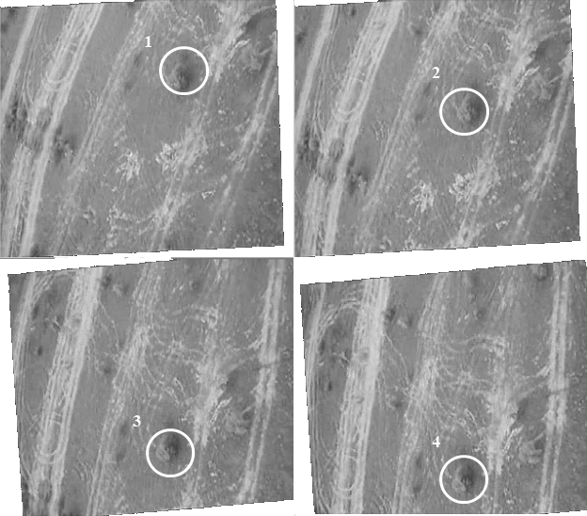Figure. 2 The results of maintaining of one object by using method of comparing histograms :
1, 2, 3, 4 - consecutive video frames, the delay between them is 25 ms.

To test the moving object classification algorithm based on interval method was selected video with the maximum number of moving objects with different homogeneity that while driving, changing their sizes (Fig. 3).
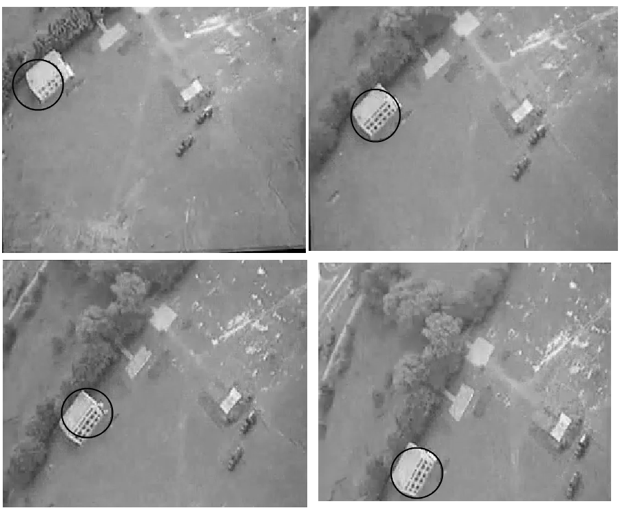 Figure. 3 Results of maintenance object procedures by Video Object Tracking program

Conclusions
Analized the existing methods of detection and maintenance of a moving object in the video. A modified based on existing classification methods and maintenance moving target: methods for moving object classification based on the estimates histogram samples and identification method of moving points in the video using frame-to-frame difference. On the basis of methods developed software Video Object Tracking technology-based Flex, performing driving a moving object in the video with different types of textures and different dynamic traffic in real time and identify the moving point.
References
1.Abdullin Yu. E. Background frame segmentation in computer vision-based motion detection // Electronic scientific journal "Investigated in Russia" – 2007. [Online resource]. URL:
http://zhurnal.ape.relarn.ru/rticles/2007/124.pdf
2. Voronoy A. Methods and ways of searching of events in the video stream. // Proceedings of the Regional Conference. "Computer monitoring and information technology. - Donetsk: Donetsk National Technical University, 2007.
3. Online resource:
http://ru.wikipedia.org/wiki/Model-View-Controller.
4. Koval M. Analysis and modification algorithms for detecting and tracking moving objects in a video stream. // Visnyk KNU named Michael Ostrogradskiy. - 2010. - № 64 - p.49-53.
5. Obukhov N. Surveillance methods, segmentation and tracking of moving objects: the dissertation for the degree of Doctor of Technical Sciences: 05.12.04 specialty "Radio" / N. Obukhov. - St. Petersburg., 2007. - 20.
6. Torubka V. Algorithm research of detecting moving aircraft on the video scene / T. Torubka, V Puyda // Computer systems and networks: collection of scientific papers - Lviv, 2011. - p. 178-181.
7. Cherkayev O. Development of methods for processing video images of objects during the long, thesis. - Donetsk: Donetsk National Technical University, 2010. Online resource:http://masters.donntu.edu.ua/2010/frt/cherkaev/diss/indexu.htm

